Australia and its Identity: History through Literature
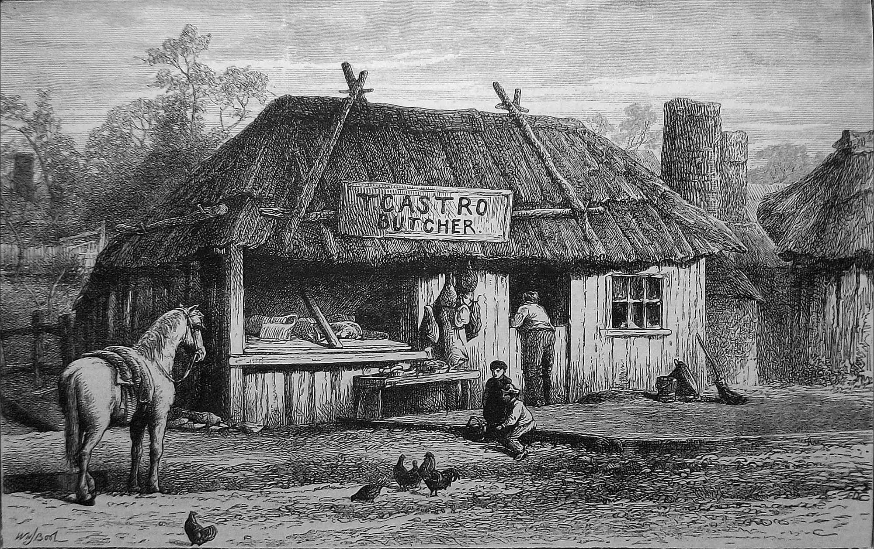  Year 6 / History and English (NSW Syllabus 2013) | Inquiry focus: Cultures, Change and Continuity, Social Systems and Structures  Sub strand: Australia and Its Identity  Focus Question for Investigation: How does identity determine worth?  Contributing Questions for Investigation: What is Australia’s Identity?  - What is identity?  - How do we use identification in the world?  - How do relationships rely on the value of one’s identity?
Goals:  Significant Events and People  • evaluates the significance of some Australian world achievements in the past and present, eg in medicine, sport, exploration, invention, the arts, human rights, considering unsung heroes  • refers to the motivating factors behind the achievements of some significant people, eg Caroline Chisholm, John Flynn  • identifies some links between events in the world and the arrival and plight of immigrant groups  • identifies places associated with nationally significant events and people  • identifies the origins of some events, days and actions of national significance to Australian citizenship, including Anzac Day, Australia Day, Survival Day and NAIDOC Week, and examines these events from different perspectives  • examines the impact of the stolen generations on all Australians  • researches some Australian human rights issues, past and present  • refers to the motivating factors behind the actions and achievements of significant groups.  Identities  • demonstrates an understanding of different viewpoints about what is an Australian identity and gives their own impressions and point of view  • identifies examples of Australian culture, eg music, literature, art  • examines some of the cultures, ideas and traditions that have influenced Australian culture and identity, including migration, trade, religion and belief systems  • examines the contributions of Aboriginal people to Australian culture and identity  • examines the contributions of women to Australian culture and identity  • examines the contributions of some migrant groups to Australian culture and identity  • identifies origins of place names and other words and expressions used in everyday language and experiences  Cultural Diversity  • describes the cultural diversity that exists in Australia today, including the languages spoken  • identifies ways in which education, religion and culture influence the viewpoints people have about their own identity in Australia  • compares cultural change in Australia with cultural change in other nations  • identifies the impact that the environment can have on any culture  • examines how cultural diversity causes cultural change, including conflict situations  • recognises examples of stereotyping, sexism and racism  • explores cultural change in their country of origin or in a country of interest  • identifies significant sites, both past and present, and the influence these have had on Australian culture and identity, eg the Snowy Mountains Scheme, the Opera House.  Roles Rights and Responsibilities  • identifies similarities between their rights, roles and responsibilities in their family and at school  • participates in creating and observing rules to protect their rights and the rights of others in the class and at school  • explains how the roles and responsibilities of family members meet family needs and that these can differ in families  • identifies different family structures, including their own, and the ways in which roles and responsibilities can vary, eg single-parent, extended, blended families, families with adopted children  • describes their responsibilities as a family, school and community member  • identifies fair and unfair practices in their school and at home. | Learning Outcomes:  CCS3.1 Explains the significance of particular people, groups, places, actions and events in the past in developing Australian identities and heritage.  CUS3.3 Describes different cultural influences and their contribution to Australian identities.  CUS3.4 Examines how cultures change through interactions with other cultures and the environment.  SSS3.8 Explains the structures, roles, responsibilities and decision making processes of State and federal governments and explains why Australians value fairness and socially just principles.  Syllabus Ref Page : 69 – 65 Support Document Page: 142-144  ----------------------------------------------------------------------------------------------  Differentiation  This guided enquiry unit, will allow students of varying abilities to work at their level to research different aspects of Australian Values and Identity.  Work will be open-ended, allowing all students to work to their capabilities. Some students will require extra support, especially in the research based tasks.  Students will use a wiki to create a group web page supporting their information. Questions will be developed requiring higher order thinking skills.  To support their PB works page they will also have to create a presentation to share with the class on the information they have gathered.  ---------------------------------------------------------------------------------------------  Christian Perspective (by Kate Bradley)  Jesus welcomed those into the family of Christ who repented from their sins. He did not judge but forgave those who were in need of new life. He spent time with people whose identity was shunned and would in fact damage identity if associated with them.  Australia has been a country built on Christian values; however it is also a country to which people escape - from convicts, to immigrants, asylum seekers and refugees. It has no real identity pertaining to any particular culture but rather as a country that allows for the reinvention of identity, the renewal of identity.  In the same way Christ provides us with renewal. He takes off the old and clothes us with the new so that we are no longer a reflection of our former selves.  --------------------------------------------------------------------------------------------  Integration and Links to other KLA’s  This unit will link with the literacy Author Study of Jackie French, Diana Kidd and Shaun Tan.  The unit concentrates on migrants in Australia and their journey in adapting to the Australian culture and the emotions and feelings of migrants through Shaun Tans picture books. They will look at Isolation due to language and cultural barriers and also investigate the treatment of Aborigines through selected books and their culture and how it’s changed due to colonisation.  ------------------------------------------------------------------------  ICT integration and skill focus  Students will use a wiki to communicate their group work. Students will work in groups and produce a Power Point presentation as part of their wiki.
Summary of task:
Students are to be supported through the Guided Inquiry Process
They will be reading, referring to and using the Historical Novel selected for each group as a basis for learning about Australian Identity and how it was formed throughout history.
This book will be referred to as they answer their Inquiry Question and combined with historical information from other groups reading different books into a broad picture of the development of Australia’s history - leading to an Australian Identity.
Students will initially experience some activities to ‘set the picture’ of What is Australian Identity?
- Icon Game
- Group Quiz
Students will read the novel and note events of significance onto a timeline - leading to inclusion onto a whole class visual Combined Timeline.
Students will pose individual research questions related to their focus within the novel.
A personal Wiki Page of ‘gathering’ and then an answer to their question will form the bulk of their written work.
Finally students will make a PowerPoint presentation to sharing their question and answer with reference to their novel with their peers.
Key dates:
Begin: Week 1 Term 2 – Icon Game and Quiz. Begin reading novels
Conclude with presentations: Week 9 Term 2
Assessment:
Formative Assessment: Class Quiz – General knowledge about Australia and our place in it. (Group task with answer cards)
Summative Assessment: Class Quiz - General knowledge about Australia and our place in it. (Group task without answer cards)
Summative Assessment: Wiki Page Answer to personal research question
Summative assessment: PowerPoint product

(Add Marking criteria for products and process)

Feedback: The wiki will be the main feedback and support structure. The class Edmodo Group will also assist with support from teachers and peers.

Phase of Guided Inquiry | What teachers are doing | What students are doing | Scaffolds/Web 2.0 tools.
 | Aussie Icon Game – Mrs Sheerman  Group Quiz – Mrs Bradley  Organise sets of novels based on reading ability grouping  Group 1: Matilda by Jackie French  Group 2: Nanberry by Jackie French  Group 3: Refuge by Jackie French  Group 4: Hunt for Ned Kelly by Sophie Masson (My Australian Story)  Group 5: Surviving Sydney Cove by Goldie Alexander (My Australian Story) | Initiate their research project.  Play game to determine what icons represent Australia to them… To the rest of the world…  Think broadly on Australia’s Identity  Join their inquiry circles based on novel choice. Edmodo small groups  Set up a personal digital Timeline  Which software and/or Sticky labels on the classroom timeline (back wall)  Complete Reflection1. (SurveyMonkey) | SLIM Reflection 1 (SurveyMonkey)  Set up Wiki  Use existing Class Edmodo Group  Timeline set up on Classroom wall (Students keep a personal timeline – mind mapping tool or other…)
 | Read novels individually - noting historical incidents or attitudes and recording on a timeline | Get the big picture of areas of interest and consider a specific area as novel is read.  Use the study guide for each novel to understand areas of study – from this to other sources  Select an area to study. | Note sources used to check historical information in the novel?  Record using the SLASA Generator  Study guide/s  Scaffold: ‘Meaningful Choice’
 | Support students to authenticate any information queries. | Build background knowledge of their topic. | Keep checking historical information with authoritative sources.  Scaffold: Jigsaw Puzzle
 | Teaching team circulates the class to provide individual help to students.  Instruction on creating questions | Create a research question and focus for their research.  Work in inquiry circles to determine themes within books  Submit Reflection 2 (SurveyMonkey) | Use of deeper sources.  Scaffold: Fat & Skinny Questions  Inquiry circles’ task: e.g. Question focus formulation  Reflection 2 (SurveyMonkey)
 | Teaching team circulates the class to provide individual help to students. | Students search deeply  Work in novel specific inquiry circles to support/share historical knowledge | Inquiry circle scaffold?  Mind mapping application?
 | Teaching team provides feedback on the wiki and Edmodo | Students answer their research question on their wiki page | Powerpoint  May be possible for them to present in other formats? Eg the ‘tea party’ display presentation on Women’s Rights.
 | Organise for Students to share final answer in a PowerPoint presentation | Students are given a chance to talk about their product or to show it, to the class, and to answer questions that demonstrate deep learning of the topic, and their awareness of their own learning processes. | Students given chance to leave feedback on product (Peer review)
 | Mrs Bradley - assess content, understanding and skills  Mrs Sheerman – SLIM reflection data and data gathering for Action Research  Teaching team culmination conversation  SLIM reflection sheets used for analysis for Evidence-based practice? | Reflection 3.  Complete Summative  Questionnaire/evaluation on Survey Monkey. | Feedback on task on wiki and Edmodo.  Reflection 3 (SurveyMonkey)

