GUIDED INQUIRY AT WORK WITH THE AUSTRALIAN CURRICULUM
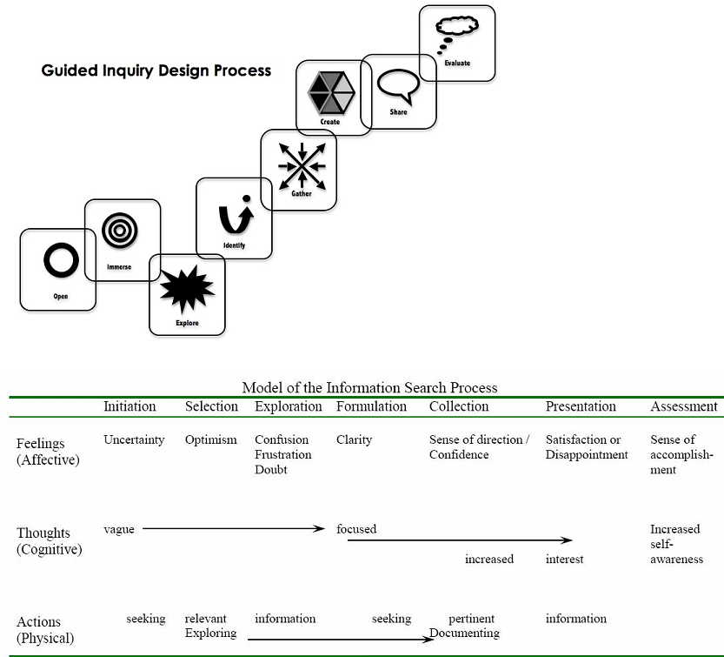 |  |  |  | UNIT OVERVIEW  - Subject/Year level  - Title of unit:  - Concept: (Big picture)
Key Inquiry Questions (from the curriculum) |  |  |  | Curriculum Skills (including general capabilities)
Key Inquiry Skills |  |  |  | Content description (from the curriculum)
Learning scenario

Assessment: Inquiry task – Overview – Description for students, with summary of key dates

Guided Inquiry Stage |  | What the teaching team is doing - Strategies |  |  | What students are doing – Tasks
Description of OPEN: Create a powerful open that invites students to engage in the inquiry topic.
INITIATION - Open

Resources

Description of IMMERSE: Students build their background knowledge by immersion in the content. Students reflect on the content and select a topic for further investigation.

SELECTION - Immerse

Resources

Description of EXPLORE: Students browse and scan through a wide range and variety of resources to explore interesting ideas around their topic. “Go broad”
EXPLORATION - Explore

Resources:

Description of IDENTIFY: Students develop an inquiry question or questions and form a focus for their research. The question or questions will frame the rest of the inquiry.
FORMULATION - identify

Resources

Description of GATHER: collect detailed information from a variety of information sources – “Go deep”
COLLECTION - Gather

Resources

Description of CREATE/SHARE: Organise their gathered information to create their product – “Tell the story”
PRESENTATION – Create / Share
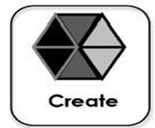

Resources

Description of EVALUATE: Students reflect on their content learning and the progress through the inquiry process.

Assessment – Evaluate |  | Culmination conversation (teaching team) |  |  | Culmination conversation (Students)
Evidence Strategies / Assessment (Formative / Summative; Informal, formal)

Rubric:
Task | Above Expected |  | Expected |  |  | Below Expected

